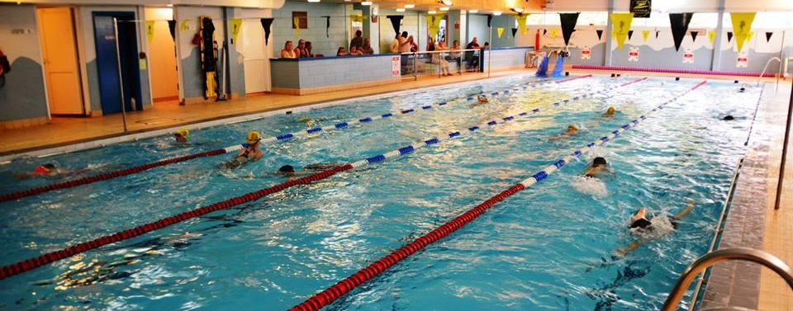

Milford Haven
Swimming Club

Welcome Pack

Introduction
All club information including training times, squad criteria, gala guides, news, results and much more can be found on our website at www.milfordtigers.co.uk we also have a Facebook page, so please come along and give us a
Coaching Team
We have a head coach in Milford alongside two Level 1 volunteer coaches and 1 trainee coach who give up their time freely.
Pool time is allocated, monitored and agreed by Pembrokeshire County Council:
Alison Marsh | Head Coach (Level 2)
Heidi Thomas | Level 1 Coach
Sarah Davies | Level 1 Coach
Richard Lewis | Volunteer Coach

If you are interested in volunteering please email mhss.memberssecretary@gmail.com or speak to a member of the committee.

Application
At the end of this pack you will find forms to be completed in order to enrol in the squad, consisting of a behaviour policy agreement for swimmers and parents to sign and a bank mandate form to set up payments for training. The club is now using a paperless system, so rather than print a copy, please ask either our membership or fixture secretary to fill out the forms with you.

Membership Fees
There are three fees that need to be paid to enable swimmers to swim competitively for Milford Tigers

- All swimmers have to pay an annual Swim Wales fee each April, this is currently (2022-2023):

Category 11 (Training) | £37.00
Category 12 (Competitive) | £39.00

- Club Membership fees of £10.00 are due on registration and annually in January - payable to the club.
Due to Covid-19, the preference is for direct bank payments. Club details are:
Milford Haven Swimming Squad
Sort Code : 20-37-82
Account Number : 20635383
- All swimmers will also need a Pembrokeshire County Council Tier membership - this is arranged through reception at the Leisure Centre. The club will advise which Tier of membership you need to take out for your swimmer.
(Please note, these are subject to change via Pembrokeshire County Council):
Pricing from 1st September 2021
Tier 1: Waterdragons (up to 2 hours per week) | £20.60
Tier 2: Club Development Squad | £28.90
Tier 3: Academy Squad | £35.80
Tier 4: Transition Squad | £40.40
Tier 5: PCS Development Squad / Sprint Performance squad | £44.90
Tier 6: PCS Performance Squad | £49.50

- Tiers 3 and above include training with the Pembrokeshire County Swimming squad

Swimming club members are eligible to:
- Junior fitness sessions and classes.
(children 13+ will also be able to access the fitness suite at all times and attend adult fitness classes).
- Public swimming.
- Discounted holiday scheme activities (25% off).
- Tier 2 and above memberships also include Rookie Lifesaving.

New Swimmer Trials
New Swimmers wanting to enter the club will require an assessment (unless they are a known competitive swimmer transferring from another club).
If the swimmer is accepted, they will be eligible for a 4 week trial to see if they enjoy the swimming club structure. After this trial they will need to enrol with the club and payments to be implemented.
Please message our Facebook page, or email mhss.headcoach@gmail.com to arrange a trial

Training Times
Our training times are below - new swimmers typically train on a Friday, building as they gain experience and move up through the squad.
Monday 6.00pm – 7.45pm
Wednesday 6.00pm – 7.45pm
Friday 6.30pm – 8.00pm
Swimmers are asked to be at the centre at least 5 minutes before the session.

Squad Structure, Progression and Kit Requirements
Please note – due to Covid-19, current squad structure has been suspended. The squad trains in two groups.
Waterdragons
Must have passed stage 6 of the Learn to swim scheme
Development 1 - To progress to Development Squad 1, swimmers must be able to demonstrate the following:
- Swim 50m Front crawl and Backstroke to include legal turns and streamline off the wall, good technique and body position.
- 25m Breaststroke with gliding and good stroke timing
- 25m Butterfly arms clearing the water with fins.
- Be able to perform legal starts and turns.
Swimmers in Development 1 will need: Fins, Kickboard, Pull buoy and a Front Snorkel
Development 2 - To progress to Development Squad 2, swimmers must be able to demonstrate the following:
- Swim 100m Front crawl to include perfect technique, 3 correct and legal tumble turns, streamline at least 5m off each turn
- Swim 100m Backstroke as above. Must also be performed with bent arm pulling action
- Swim 100m Breaststroke to include legal pull out, legal turns, gliding and efficient stroke timing.
- Swim 50m Butterfly so that arms clear the water, correct stroke timing & 5m streamline out of turn.
- Swim a 200m IM to maintain technique across all strokes, Correct IM Turns
Swimmers in Development 2 will need: Fins, Kickboard, Pull Buoy and a Front Snorkel
Development 3 – Entry into Development Squad 3 is at the discretion of the Head Coach
Swimmers in Development 3 will need: Fins, Kickboard, Pull Buoy, Front Snorkel & Hand Paddles
Progression through the squads will be initiated by a continuous assessment process.
Swimmers will progress when coaches feel they are ready and have met the above criteria.

Quick Gala Guide
Please note a full gala guide is available on our website. No galas should be entered without club permission.
Team Events
These are galas where you swim as part of a team for Milford Tigers. They are inter-club events often against other Pembrokeshire swimming clubs. They are a great opportunity to gain competition experience in a friendly environment, to swim as part of a team, be encouraged by and encourage your fellow team mates, and have a bit of fun on poolside. There is no cost to enter.

In House Galas (Club Champs & Colours Gala)
We ask all swimmers to enter these events.
Club Champs – these offer the chance to break club records, receive trophies and medals all in the friendly atmosphere of the club. It is a good way for new swimmers to experience a gala. Medals and trophies are presented at our Presentation evening.
Colours Gala - this is like a Sports Day for swimmers – it’s purely fun based and includes coaches’ races, novelty races, and relays.

Pembrokeshire League Galas
The Pembrokeshire League is a series of galas run by Pembrokeshire County Swimming involving all 6 of the County clubs – Milford Haven, Haverfordwest, Fishguard, Tenby, Pembroke and Preseli in rounds. These are a fun series of galas for all swimmers to enter, winning points for the team & a great introduction to racing.
Every swim completed wins points for the club which is why entering the Pembrokeshire League galas is mandatory for all squad members.

Open Meets
These are for swimmers to gain and update licensed times for all strokes and distances.
They are events organised by other clubs (e.g. Swim Swansea Open), the county (Pembrokeshire County Championships) or an organising body (West Wales/Swim Wales). Notification and Meet Packs for these events are put on the notice board and on our website as early as possible, often some months before they take place. The Meet pack contains all the information you will need, the dates, venue, programme of events, necessary qualifying times and the cost per swim – these events are not free to enter. Additionally, if it is needed, an eligibility report of your entitlement to swim will be produced by the club and posted on the website/notice board.
All of this can be very confusing to start so we will try to help you where we can - please contact us anytime to discuss any queries you many have.
Information and advice (for a particular swimmer) can be obtained from:
The Fixture Secretary
The Coaching Team
Fees are due on entering your child for an event. Please pay promptly via BACS to the club bank account.
Information & Queries
We are here to help with any queries you may have. You can always seek advice from the coaching team or our committee members. Email addresses to contact team members are below.

Committee Members
Chair | Neil Arnold | mhss.chairperson@gmail.com
Club Secretary | Meg McFarlane | mhss.secretary@gmail.com
Treasurer | Owain Davies | mhss.clubtreasurer@gmail.com
Membership Secretary | Vicki Lloyd-Roberts | mhss.membersecretary@gmail.com
Child Welfare Officer | Sarah Starling | mhss.clubwelfare@gmail.com
Team Manager / County Rep | Heidi Thomas | mhss.teammanager@gmail.com
Head Coach | Alison Marsh | mhss.headcoach@gmail.com
Fixtures Secretary | Karen Burton | mhss.fixture.sec@gmail.com
Fundraising Secretary | position open | mhss.clubfundraising@gmail.com

Club Shop
Our club shop is available online at St Brides Bay Clothing www.stbridesbay.com; you can order over the phone 01646 696904 or by calling into the shop at Agamemnon House, Nelson Quay, Milford Marina
Club t-shirts are yellow (swimmers need to have these for galas when on poolside. The “performance” t-shirt is better quality)
Club Sweatshirts are black (These are not essential but handy to keep warm after training in the winter).
Complaints procedure
Most of our coaches and committee members are volunteers, therefore if you have a complaint please respect their volunteer status. Issues can be raised with coaches and/or committee members but if you have a complaint please forward in writing to our club committee chair email address mhss.chairperson@gmail.com so we can deal with it calmly & fairly.
Unless deemed urgent, your issue/complaint/query will be discussed at our next committee meeting usually 1st Thursday of every month. We will then contact you by email and, if appropriate, arrange a convenient meeting to discuss.
If you would rather speak face to face, we have a welfare officer – Sarah Starling. She may not be able to answer/deal with your issue immediately but can bring it to the attention of the committee on your behalf. Committee members are quite often at the pool when their children swim and can be approached anytime for a chat. If you don’t know who the specific people are, let any coach know and they will point them out.
Full information on our complaints procedure can be found on our website.

Any further questions?
Please do not hesitate to contact anyone on the committee if there are any other queries that you have.

Welcome to Milford Tigers!

Membership
This pack contains all the forms and information that you will need to enrol with Milford Tigers.

Registration Form
Name of Swimmer
Address
Postcode
Date of Birth
Telephone Number
Email Address

Emergency Contact & Medical Information

Name of Swimmer
Primary Contact
Contact Number
Relationship to Swimmer
Secondary Contact
Contact Number
Relationship to Swimmer
Medical Information
(Including any medication / disabilities)
Allergy Information

Club Publicity
From time to time Milford Tigers wish to promote its activities and achievements through press reports, Facebook and on our website.

Please indicate below if you are willing for the following:
(delete as appropriate)

Have Name Published | Yes / No
Have Photograph Published | Yes / No
Be Video Recorded | Yes / No

Parental / Swimmer (over 18) agreement:

- I agree to notify Club officials, teachers or coaches of any changes in the above circumstances
- I also agree that *my child / *I shall be bound by the club rules

Parent / Guardian Signature
Swimmer Signature
Date

